Reedness Parish Council
Oaklands, Ousefleet, Goole, East riding of Yorkshire, DN14 8HR
07402987788
reednessparishcouncil@gmail.com
7th January 2026
Dear Councillors,
You are summoned to attend the next meeting of Reedness Parish Council to be held on Wednesday 14th January 2026 at 7pm at Reedness Primary School.
The official Parish Council Meeting will commence at 7.10pm. Prior to this at 7.00pm any members of the public attending the meeting may be given (at the Chairperson’s discretion) a combined 10 minute time slot to address the Councillor’s on any items of concern or interest. After this period the public are welcome to stay for the full Parish Council Meeting but CANNOT speak or offer advice/opinion on any matter. The public participation item is NOT part of the formal Parish Council Meeting and as such there are no rights to record this part of the meeting in any way.
AGENDA
- To receive apologise for absence

- To receive all declarations of interest on any agenda items

- To confirm the minutes of the meeting held on 12th November 2025 are a true and correct record

- Ongoing issues

- Suggestions box – to receive and discuss contents
- Defibrillator – to discuss any issues including replacement battery and confirm contents
- Highways concerns – update to be given by the Clerk
- Speed Indicator Devices – update to be provided by Clerk
- Choking devices – Cllr’s to highlight any issues and confirm contents
- Kiosk damage – Cllr Dixon to provide and update.

- Correspondence received/issues raised by Councillors

- Defibrillator Event/First Aid Community Event – Cllr’s to discuss
- Neighbourhood Watch – Clerk to provide an update of December Newsletter
- Code of Conduct – issued to Councillors via e-mail for consideration
- Zig-zags and parking outside Reedness School at the Whitgift end of the village
- Christmas tree/Festive Light Competition – Cllr’s to discuss plans and consider any criteria which are to be put in place for judging the 2026 Festive Light Competition. Cllr’s to consider suggestions for an independent judge for 2026.
- Remembrance poppies – Cllr’s to discuss poppies being created by members of the local community and Reedness Primary School to create a display in the village

- Planning Applications and decisions
Planning Consultation for 25/03438/OUT Land East of Bank End, Main Street, Reedness, East Riding of Yorkshire, DN14 8HG – consultation received (sent to Cllr’s via e-mail 08/01/26)
Notification of Desicision on App Ref – 25/02787/PLF – approved (e-mail received 13/01/26)

- AOB

Ward Councillor’s Report
Flood Warden Report
ERNLLCA Councillor Induction Training
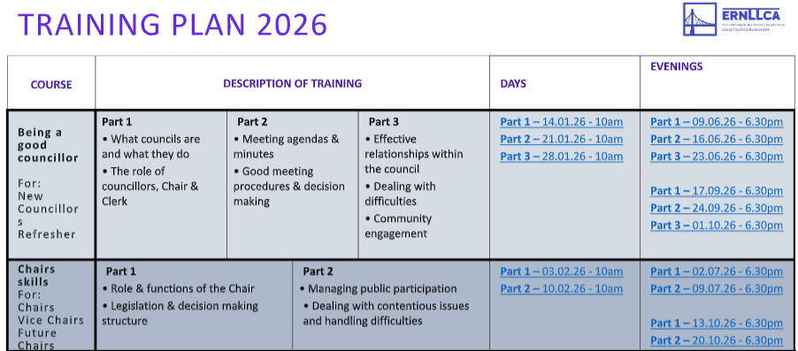

- Finance and confidential matters

A: updated HSBC mandate form for Council to be signed by signatories
B: Precept – Cllr’s to discuss and approve the 25/26 precept. The Chairperson will sign the precept request document and the Clerk will notify ERYC by Friday 16th January 2026.

Cheques to be approved for payment

100518 £300 Incredible Edible
100519 £258 S C Freeman – Defibrillator battery
100520 £160 S C Freeman – Village Christmas trees
100521 £13.60 L Gibson – Post Office - 8 X 1st class stamps

Date of next meeting Wednesday 11th March 2026 at 7pm, Reedness Primary School.

