Reedness Parish Council
Oaklands, Ousefleet, Goole, East riding of Yorkshire, DN14 8HR
07402987788
reednessparishcouncil@gmail.com
4th March 2026
Dear Councillors,
You are summoned to attend the next meeting of Reedness Parish Council to be held on Wednesday 11th March 2026 at 7pm at Reedness Primary School.
The official Parish Council Meeting will commence at 7.10pm. Prior to this at 7.00pm any members of the public attending the meeting may be given (at the Chairperson’s discretion) a combined 10 minute time slot to address the Councillor’s on any items of concern or interest. After this period the public are welcome to stay for the full Parish Council Meeting but CANNOT speak or offer advice/opinion on any matter. The public participation item is NOT part of the formal Parish Council Meeting and as such there are no rights to record this part of the meeting in any way.
AGENDA
- To receive apologise for absence

- To receive all declarations of interest on any agenda items

- To confirm the minutes of the meeting held on 14th January 2026 are a true and correct record

- Ongoing issues

- Suggestions box – to receive and discuss contents
- Defibrillator – to discuss any issues including replacement battery and confirm contents
- Highways concerns – update to be given by the Clerk
- Speed Indicator Devices – update to be provided by Clerk
- 20mph zone – update to be provided by clerk
- Choking devices – Cllr’s to highlight any issues and confirm contents
- Kiosk damage – Cllr Dixon to provide and update.

- Correspondence received/issues raised by Councillors

- Defibrillator Event/First Aid Community Event – Cllr’s to discuss and select a date so that plans can progress
- Neighbourhood Watch – Clerk to provide an update on enquiry made regarding starting a Neighbourhood Watch group.
- Rememberance Poppies – Clerk to provide an update and Cllr’s to discuss next steps and timeline
- Village flag pole – Clerk to present designs created by children of Reedness Primary School and winner(s) to be selected.
- AGAR 25 – requirements to be shared with Cllr’s.

- Planning Applications and decisions
There were no planning applications received at the time the minutes were typed. The planning portal will be checked prior to the parish meeting on 11.03.26.

- AOB

Ward Councillor’s Report
Flood Warden Report
ERNLLCA Councillor Induction Training – Clerk to provide confirmation that Cllr Freeman has been booked on the requested training.
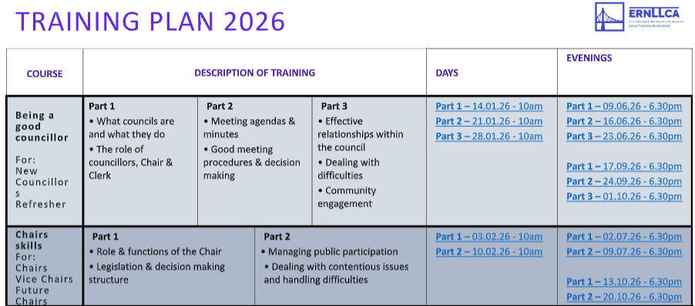

- Finance and confidential matters

A: HSBC mandate form for Council – update to be provided by Clerk
B: Precept – Confirmation of receipt from ERYC. Clerk to provide update of payment dates.
C: Card Application for Parish Council HSBC bank account.

Cheques to be approved for payment

100522 Clerks wages
100523 VOIDED
100524 £350 HMRC
100525 £419.17 Zurich
100526 £300 East Riding of Yorkshire Council

Date of next meeting Wednesday 13th May 2026 at 7pm, Reedness Primary School.

